

EMPLOYEE LEAVE AND PAYROLL MANAGAMENT SYSTEM – Sprint 1

Course: Software Engineering
Instructor: Ms. Rabail Zahid

Submission Date: 28th February 2025

BY:
The Scytes
Ruhab Ahmad (23I-0559)
Hasan Altaf (23I-0698)
Muhammad Saqib (23I-0769)

Sprint 1 Module
Authentication & Employee Management Module

User Stories
US-01 Login System
As an HR Admin
I want to login securely
So that I can access the system
Sub-tasks:
- Validate credentials
- Create session
- Redirect to dashboard
US-02 Add Employee
As an HR Admin
I want to add employee records
So that employee data is stored
Sub-tasks:
- Enter employee details
- Validate input
- Save to database
US-03 View Employee List
As an HR Admin
I want to view all employees
So that I can manage records
US-04 Logout
As a User
I want to logout
So that my session ends securely

Structured Specifications
- Login User
Inputs: username, password
Process:
- Validate input
- Check database
- Create session
Output: dashboard / error
- Add Employee
Inputs: name, ID, salary, department
Process:
- Validate fields
- Store in database
Output: success message
- View Employees
Inputs: request from admin
Process: fetch all records
Output: employee list
- Logout
Inputs: logout request
Process: destroy session
Output: login page

SCRUM BOARD
- Initial backlog uploaded:
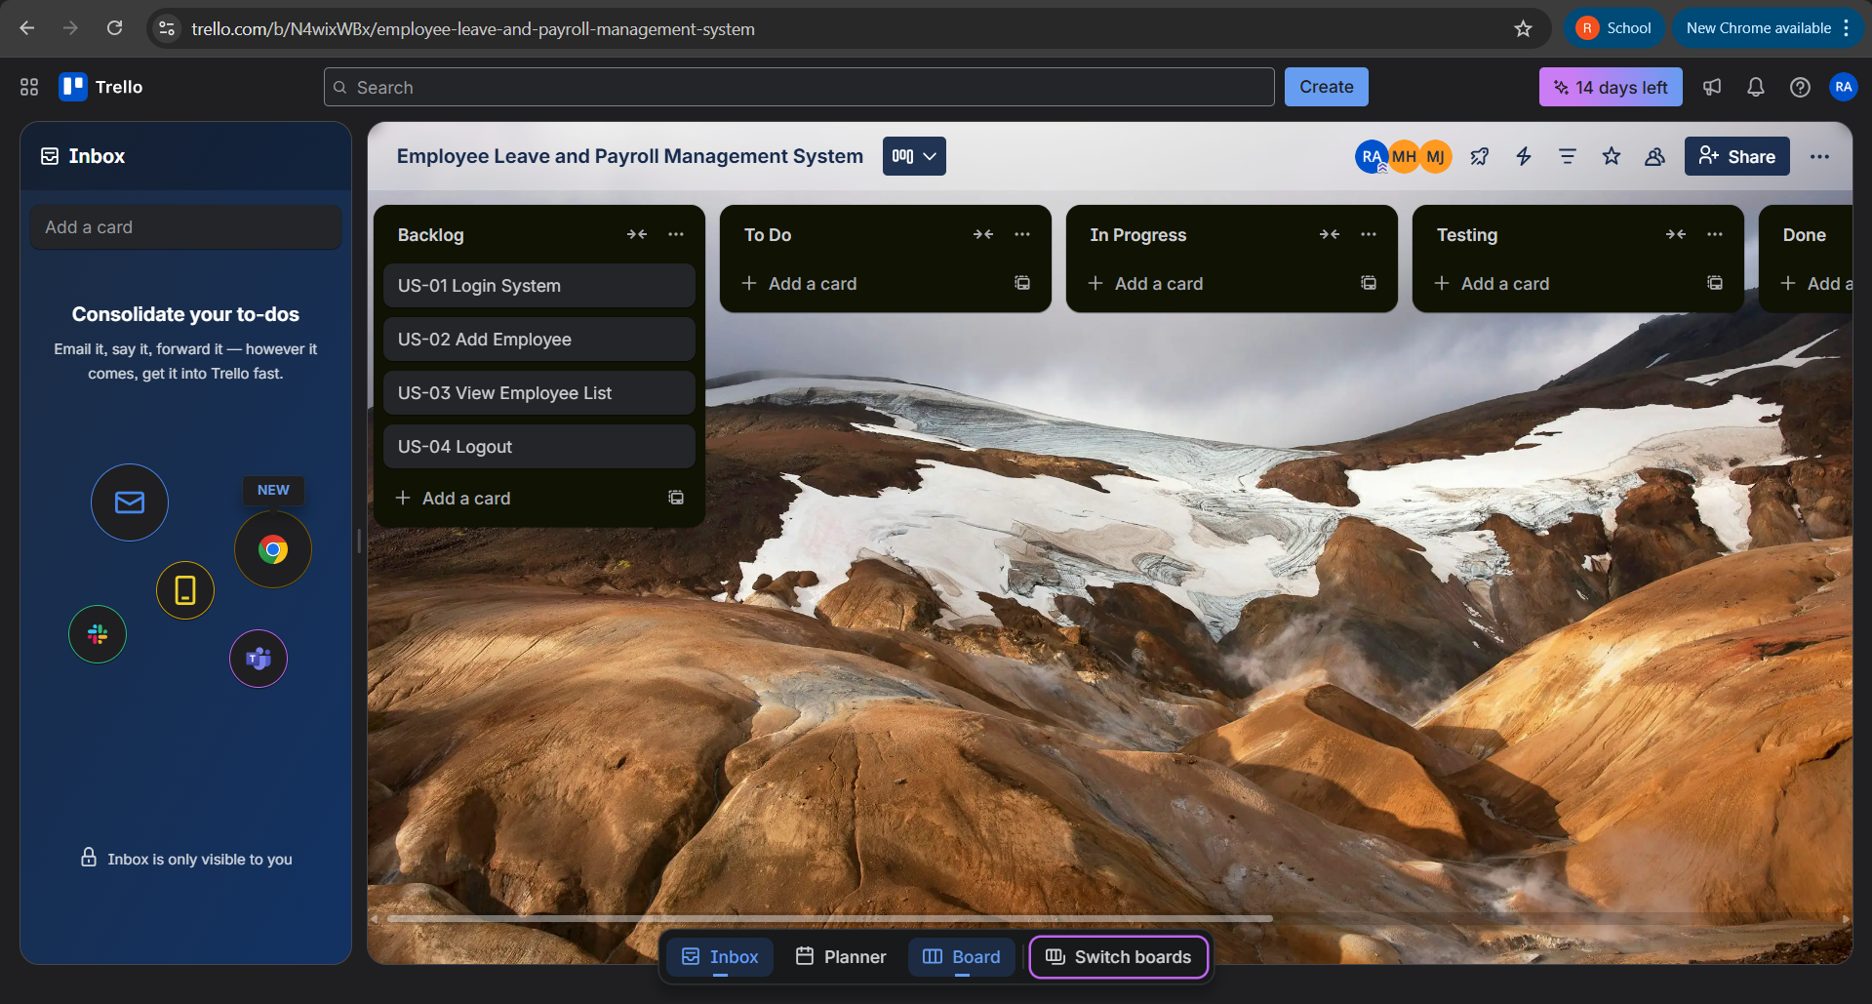

- Mid-sprint progress:
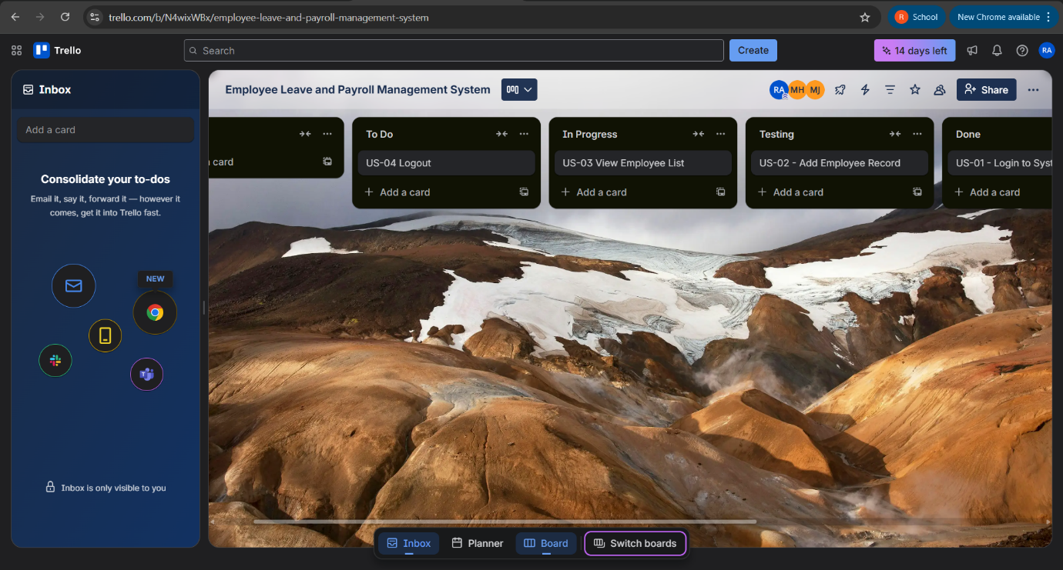
- Final sprint status:
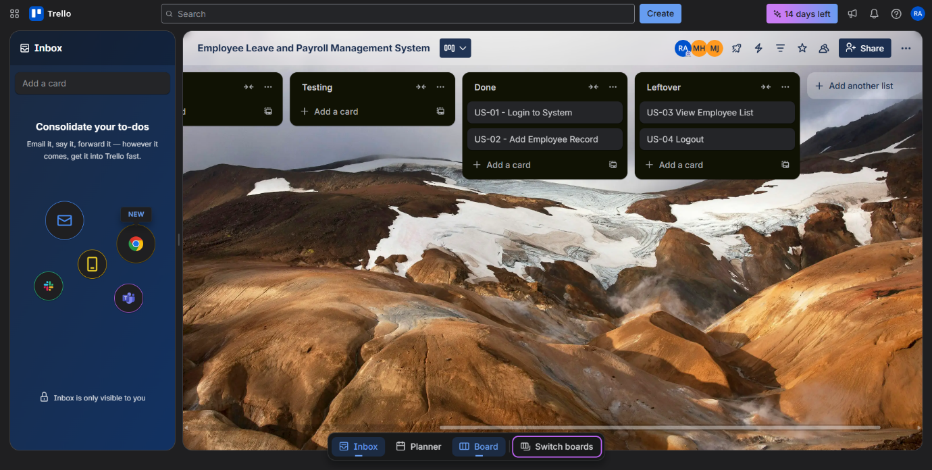

Product Burn-Down Chart
